**Hazing in Greek Life**

Jordan Barth

May 2, 2018

**Introduction**

Greek organization have frequently been in the news as of late, for all of the wrong reasons. Just last year, Penn State’s Tim Piazza (Rossman 2018, Flanagan 2017), LSU’s Max Gruver (2017), Texas State University’s Matthew Ellis (King and Duncan 2017) died from actions (or lack their of) taken by fraternity "brothers" while being initiated into their respective fraternities. As a result, Greek organizations face greater risk of suspension by universities and their national organizations (Myers 2018), former members now face criminal charges in some instances (Snyder 2017), and Greek life has come under scrutiny by all parties involved across the country(McMurtrie 2015). Hazing on college and university campuses is a major issue that administrators are just starting to seriously grapple with (Mangan 2017). This paper makes a strong contribution to the hazing literature by providing a baseline for measuring the problem and will hopefully help administrators, Greek leaders, parents, students and others make Greek life safer and more enriching for all parties involved.

**Defining the Problem**

*What Are Greek Organizations?*

On most college campuses, Greek organizations are usually broken down into fraternities (males) and sororities (females). The Greek institution writ large is divided into three categories: professional organizations, honor societies, and social organization. Professional fraternities and sororities bring students together on the basis of shared professional/career interests. As the name suggests, honor societies are composed of students who have achieved distinction in academia. Many of the organizations that have been sanctioned however are the social fraternities and sororities (DeSantis 2007). It is organizations in this category that often come to mind when the public thinks of Greek life. They are most commonly associated with big parties, pledging, and hazing, and communal housing. Each organization has its own distinctive culture but all are highly secretive and ritualized (DeSantis 2007).

There are redeeming aspects of Greek organizations. Greeks are more likely to be involved in and satisfied with campus social life, graduate, and have higher rate of degree persistence(Walker, Martin, and Hussey 2015, Routon and Walker 2016). In addition, many choose to join these organizations for professional development and network they provide. Male Greeks earn about $6,000 more per year than male non-Greeks (Routon and Walker 2016). DeSantis (2007) notes that Greek alum "dominate the elite realms of politics, law, and business." In addition, he mentions that Greek alum make up 76 percent of U.S. senators; "71 percent of the men listed in Who's Who in America; and 85 percent of the Fortune 500 executives” (6).

However, it can not be overlooked that many Greek social organizations often serve as the party hub on many college and university campuses. O’Brien et al. (2013) found that Greeks are more likely to get injured or injure someone else, adjusting for drinking behaviors. In addition, many studies found Greeks are disproportionately more likely to drink and in heavier quantities along with similar patterns for drug use than non-Greeks (Scott-Sheldon, Carey, and Carey 2008, Chauvin 2012).

*What is hazing and why does it occur?*

Hazing is defined as the "abuse of new or prospective group members (collectively, “newcomers”)."(Cimino 2011, 241). Hazing in Greek organization can be divided into two types, physical and psychological, and often observed in terms of masculinity. It often occurs in “group-interaction processes that are linked with students' need for belonging, their isolation from other social relations on campus, and subcultural definitions that legitimate hazing events as a necessary component of fraternity initiation rites” (Parks et al. 2015). Why hazing occurs is complex and often differs by organization.[1] Some publications have suggested social psychology’s heavy influence in the hazing process (Parks and Southerland 2013). Others have noted students’ need for belonging and wanting to fit in – to the point of withstanding punishment (Parks et al. 2015). Others provide more cultural and sociological definitions that are worthy of consideration (Cimino 2011).

Regardless of explanation, hazing’s danger does not start off immediately. Scholars note a number of factors that may explain why hazing has remained a part of Greek life. Social conformity, obedience to authority, organizational identification, group effects and the need for acceptance, connectedness and esteem may help to explain the persistence of hazing rituals (Parks and Southerland 2013). White fraternities and sororities purposefully use hazing in order to break down potential new members, remove their existing identities and social connections, and rebuild them in the image of the Greek organization with a new identity (Parks et al. 2015). Those being hazed may begin with a relatively harmless activity and then find themselves increasingly moving towards more extreme behavior, unable to say no. Escalating commitment and a desire to act consistent with prior decisions may all contribute to making it difficult to find another path (Silveira and Hudson 2015). In addition, the illusion of control and overconfidence may mean that participants discount the possibility of hazing's having bad outcomes. Even participants who are disturbed by hazing rituals may not speak out, due in part to pluralistic ignorance, or the misperception of social norms.

The literature suggests that its often a combination of social psychology, adolescent development, and cultural norms that provides ripe conditions for Greek organizations to haze new members. Long standing traditions exist in Greek organizations that, given little oversight from universities and the national organization, go way too far (Mangan 2017). This, combined with the potential after-glow/relief of having survived hazing rituals, feeling a sense of accomplishment, experiencing the respect of their peers allows the practice to continue.[2] In addition, given their developing brain, adolescents may be unable to fully envision the consequences of their actions (made worse by lack of oversight) (Santrock 2014). This, combined with greater alcohol consumption by Greeks and prevalence of social psychology’s groupthink in large groups enables Greek organizations to behave so poorly when adding to their organizational ranks.

**Data and Methodology**

I obtained much of my over 400 observations through viewing websites' of institutional offices of campus life and viewing coverage of hazing incidents by campus, local, regional, and some national publications from 2015 to 2018. This period of time was chosen for two reasons. First, Caitlin Flanagan's "The Dark Power of Fraternities" in *The Atlantic* was published in 2014 (Flanagan 2014). The article illustrated for all who read it the dangers, power, and politics of Greek life and started changing public perceptions toward Greek Life. Second, Sigma Alpha Epsilon, recently the subject of reporter John Hechinger's latest book, banned pledging and initiations (Hechinger 2017).

Finding stories and coding was the most challenging and time-consuming part of this project. After viewing a pertinent article, I coded the organization name, whether it was a fraternity or sorority, date, month, year, whether they were investigated or sanctioned, what kind of sanction they received and when their sanction was scheduled to end by. Most stories and Office of Campus Life websites did not have all the information I needed so I had to cross check pieces of information. Some universities post status of Greek organizations but its often incomplete or quite scattered. Exact dates of when investigations or sanctions started or ended were tough to come by. Given the information I had, if a publication said

* Fall (insert year here)- I coded the start date for August 15 or September 1 (depending on when the institution started their semester). End date was coded December 31.
* Spring (insert year here)- Start date was coded as January 1 or 15 and end date was coded as May 15 or 31.

I faced some other additional methodological challenges. While this study only looks at hazing, heavy alcohol usage usually is part of hazing rituals. Some universities consider it a separate violation while others consider it part of a hazing violation. The same issue came up when an institution or article reported “health and safety violation” or “policy violation”. Hazing endangers one’s health and safety and hazing is a policy violation – it is unclear what an organization is being sanctioned for.

Breaking down organizations and the type of sanctions they received was tougher. Keeping the nuance of the individual organization’s sanctions but operationalizing them enough for data analysis and validity was difficult. I’ve included the possible sanctions an organization can receive given my criteria.[3]

* *Cease and Desist*: Cease and desist requires the chapter to temporarily stop all activity while an investigation is pending, Activities include but not limited to individual initiated member/new member gatherings, recruitment events, social events, and new member meetings. Any business must be pre-approved by the institution's Office of Campus Life.
* *Disciplinary Probation*: An organization is not in good standing with the University after having been found responsible for serious violations of policy or subsequent violations after prior disciplinary action. Any violations may result in the revocation of the organization’s recognition. Organizations may conduct operations as usual unless specified in the organization’s sanctions.
* *Social Probation*: Chapters are not permitted to coordinate and/or hold social events with alcohol. This includes social functions with alcohol in the chapter house, brothers' homes, or third party venues. In addition, recruitment, new member education, and other chapter activities may be curtailed.
* *Suspension*: The organization's recognition is suspended by the University for a specified period of time. Further violations could result in the permanent revocation of the organization’s recognition.

**Results and Analysis**

My results, while I was unable to complete attractive looking graphics as I had hoped for, are quite interesting. I was able to collect 475 observations. As shown in Figure 1, 394 of the observations were of sanctioned fraternities. There were only 80 cases of sorority sanctions and 1 case of co-ed.

**Figure 1: Number of Greek Organizations Sanctioned**

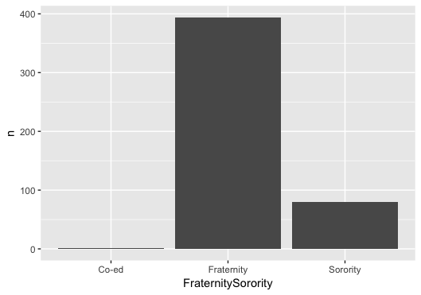

In line with my expectations, given the increased media coverage on hazing, 2017 saw the most organizations sanctioned (307), as shown by Figure 2. An interesting note, we are almost a third of the way through 2018 and there are 104 cases of sanctions already. This suggests that many more organizations may be suspended or investigated for hazing in the near future.

**Figure 2: Sanctioned Organizations (by year)**

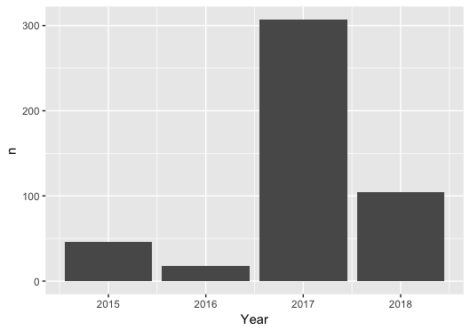

In Table 1 and 2 below, I’ve provided a breakdown of sanctioned chapters by organization and college/university. Unsurprisingly, Sigma Alpha Epsilon is first with number of sanctioned chapters. The organization has come under a lot of recent pressure to start fresh practices amongst their chapters. In addition,

**Table 1: Number of Sanctioned Chapters (by Organization)**

|  |  |
| --- | --- |
| Sigma Alpha Epsilon | 18 |
| Pi Kappa Alpha | 16 |
| Sigma Chi | 15 |
| Phi Kappa Psi | 14 |
| Pi Kappa Phi | 14 |

**Table 2: Number of Sanctioned Chapters (by Campus)**

|  |  |
| --- | --- |
| Florida State University | 54 |
| Pennsylvania State University | 45 |
| Louisiana State University | 42 |
| Ohio State University | 38 |
| Indiana University | 37 |
| Miami University (OH) | 37 |
| Texas State University | 31 |
| University of Missouri | 27 |
| University of Michigan | 20 |
| West Virginia University | 17 |

As shown in Figure 3 below, organizations were most likely to receive a temporary cease and desist order (201) while the institution or national organization investigates potential allegations. Suspension of chapter recognition was the second most likely sanction to be taken by the chapter’s national organization or the institution (171). In addition, one should note that note all organizations that were investigated were formally suspended for a period of time post-investigation. that received a suspension

**Figure 3: Number of Sanctions (by type)**

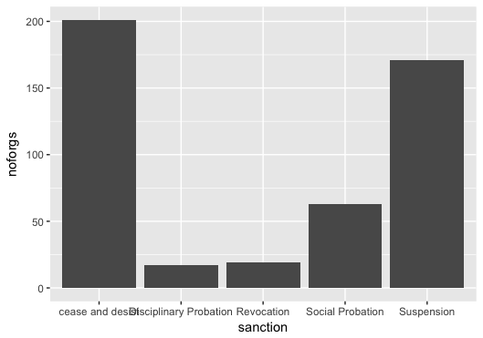

My final figure illustrates how the organizations are spatially distributed across the US. I located coordinates of all institutions with sanctioned Greek organizations and have plotted them below. While I was unable to add state boundaries and weight by campuses with the largest number of sanctioned organizations. One can see that hazing predominantly occurs in the Northeast. One explanation for this is the large amount of wealth in the northeast and potential new members of Greek organizations often come from wealthy households.

**Figure 4: Spatial Distribution of Sanctions**

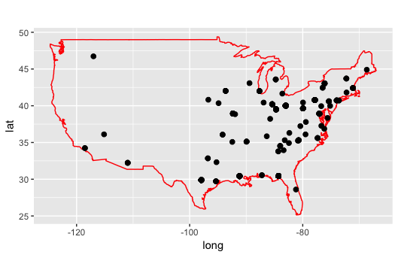

**Future Research**

Future research could include expanding the dataset of institutions and expanding the time frame of study. In addition, I was unable to create a choropleth map prior to deadline but, hope to do so in the future. Finally, I was able to expand my data set to calculate the days between start and end date of sanction – demonstrating length of suspension. However, I was unable to show write the necessary code and create a visual in time.

Works Cited

2017. "LSU Students to be Arrested in Connection to Max Gruver's Death." *University Wire*

Chauvin, Chantel D. 2012. "Social Norms and Motivations Associated with College Binge Drinking." *Sociological Inquiry* 82 (2):257-281. doi: 10.1111/j.1475-682X.2011.00400.x.

Cimino, Aldo. 2011. "The Evolution of Hazing: Motivational Mechanisms and the Abuse of Newcomers." *Journal of Cognition and Culture* 11 (3-4):241-267. doi: 10.1163/156853711X591242.

DeSantis, Alan D. 2007. *Inside Greek U: fraternities, sororities, and the pursuit of pleasure, power, and prestige*. Lexington: University Press of Kentucky.

Flanagan, Caitlin. 2014. "The Dark Power of Fraternities." *The Atlantic*, March 2014, 72-91.

Flanagan, Caitlin. 2017. "A Death at Penn State." *The Atlantic*, November 2017, 92-105.

Hechinger, John. 2017. *True Gentlemen: The Broken Pledge of Americas Fraternities*. New York: PublicAffairs.

King, Gayle, and Jericka Duncan. 2017. "Matthew Ellis, Texas State University Student, Dies on Monday." *CBS This Morning*.

Mangan, Katherine. 2017. "Colleges Confront the Perils of Frats." *The Chronicle of Higher Education*.

Mann, Liesbeth, Allard R. Feddes, Bertjan Doosje, and Agneta H. Fischer. 2016. "Withdraw or affiliate? The role of humiliation during initiation rituals." *Cognition and Emotion* 30 (1):80-100. doi: 10.1080/02699931.2015.1050358.

McMurtrie, Beth. 2015. "Do Fraternities Have a Place on the Modern Campus?" *The Chronicle of Higher Education*.

Myers, Michele Tolela. 2018. "Let's End Hazing Deaths Now." *The Chronicle of Higher Education* 64 (19):A48.

O’Brien, Mary Claire, Robert S. McNamara, Thomas P. McCoy, Erin L. Sutfin, Mark Wolfson, and Scott D. Rhodes. 2013. "Alcohol-related injury among Greek-letter college students: Defining a target population for secondary prevention." *Journal of Health Psychology* 18 (4):461-469. doi: 10.1177/1359105312446767.

Parks, Gregory S., Shayne E. Jones, Rashawn Ray, Matthew W. Hughey, and Jonathan M. Cox. 2015. "White boys drink, black girls yell: a racialized and gendered analysis of violent hazing and the law." *Journal of Gender, Race and Justice* 18 (1):93.

Parks, Gregory S., and Tiffany F. Southerland. 2013. "The psychology and law of hazing consent." *Marquette Law Review* 97 (1):1.

Rossman, Sean. 2018. "A year ago, Penn State's Tim Piazza died, and his parents aren't letting up." *USA Today (Online)*.

Routon, Wesley, and Jay Walker. 2016. "Going Greek: Academics, Personal Change, and Life after College." *Change: The Magazine of Higher Learning* 48 (1):60-66. doi: 10.1080/00091383.2016.1121088.

Santrock, John W. 2014. *Adolescence*. 15 ed. New York: McGraw-Hill Education.

Scott-Sheldon, Lori A. J., Kate B. Carey, and Michael P. Carey. 2008. "Health behavior and college students: Does Greek affiliation matter?" *Journal of Behavioral Medicine* 31 (1):61-70. doi: 10.1007/s10865-007-9136-1.

Silveira, Jason M., and Michael W. Hudson. 2015. "Hazing in the College Marching Band." *Journal of Research in Music Education* 63 (1):5-27. doi: 10.1177/0022429415569064.

Snyder, Susan. 2017. "Most-serious charges against 8 dismissed: District judge lets lesser counts stand in Tim Piazza death. DA vows to refile involuntary manslaughter." *Philadelphia Inquirer*.

Walker, Jay K., Nathan D. Martin, and Andrew Hussey. 2015. "Greek Organization Membership and Collegiate Outcomes at an Elite, Private University." *Research in Higher Education* 56 (3):203-227. doi: 10.1007/s11162-014-9345-8.

1. Not all fraternities and sororities haze their members. Countless organizations treat their members with respect and raise thousands of dollars for charity. Yet, hazing is prevalent enough that it leaves a black mark on responsible organizations and serves as a major point of discussion in the fraternity and sorority life community.
2. Academia has shown that hazing brings unity rather than division to groups, a notion that hazing is predicated on (Mann et al. 2016).
3. I’ve based my sanctions off that used by Tufts University.